

WORK-LIFE BALANCE

PROFESSIONAL PRACTICES REPORT

Wednesday (3:10-5:10)

**Group Members:**

Muhammad Haseeb (33444)

Ibrahim (33345)

Muhammad Danish (35132)

Syed Umair Shah (34640)

Syed Shayan Ali (33679)

Waqar Hussain (33628)

**Submitted To:**

Dr. Salima Ahsan

**Introduction**

We are living in the age of science and technology. We

see many wonderful inventions around us their numbers

are increasing day by day but unfortunately these

inventions have taken our personnel life away from us.

We have become busy In social media like facebook ,

whatsapp and many social sites.

We want to give time to our family and work both

But our work has become our shadow even when we are

with our family we think about work so for this reason

Lisa, Amanda and Angela have written a book called

Work Psychology to balance work and life

The study of how people think and behave at work is

called work psychology

Strategies For Work life balance.

To balance our work and life we have three strategies

that we have to follow

1) Schedule Your Time

The one thing that you have to do is to schedule

your time. Take your diary and pen and write

down which part of your time you have to give

to your family and which part of your time you

have to give to your work

2) Give Time For Your Self

Enjoy every moments of life and for one

moment leave the future and enjoy the present

3) Leave Work at Work

Do not make your work your shadow. If you are

working on some project , focus on that project

100% but when you are on some vacation , do

not think about that project at that time

Work Life Balance Creates Motivation

Work life balance has great importance to create

motivation.

According to the book the writer was involved in a work

he did not like and was neither interested. So he created

the interest in that work instead of leaving it. And he

used different ways to create interest

The writer was drawing something on the paper but he

hates drawing so as he drew . He knew that his drawing

was bad so he showed the drawing to that person who

was not expert in drawing but fond of drawing , in this

way that person praised the writer’s drawing and writer

got motivated and created interested in drawing.

**People at work**

Step 1: Set Your Priorities

Figure out what you want your priorities to be, not what you think they should be. Ask yourself, "If I could only focus on one thing in my life, what would it be?"

That answer is your top priority. What would you focus on second? Third? Fourth? Fifth? You've now identified your top five priorities.

**Step 2: Concentrate on One Thing at a Time**

* Forget multi-tasking. It's not possible to focus on two things at the same time. Instead, devote your full attention to the task at hand.
* When you are working, work. When you are spending time with your family, focus solely on them.

**Step 3: Take a Look at Your Personal Habits and General Lifestyle**

* Lack of sleep, poor nutrition, and bad exercise habits can cause you to feel a lack of balance in your life, and can counteract any efforts you are making to achieve work-life balance.

**Step 4: Ask for Support**

* Tell your boss, family, friends, colleagues, and anyone else involved in your life that you are seeking a better work-life balance.
* Tell them what your plan is, and ask them to respect it.

**Step 5: Set Boundaries**

**The Group at Work**

Group is a very familiar word but a difficult concept to define. It is a word that is used so often but there is no universally accepted meaning of what a group is.

In an effort to define a group many different definitions of group, each of which describe a group depending on its most important characteristics.

Any number of people who interact with each other and perceive themselves to be a group.

**Types of Groups**

1. Formal Group
2. Informal Group

**Formal Group:**

It is a group that has well-defined rules and regulation for joining the group, staying in the group and leaving the group. Those, who fulfill these rules and regulations, can join and engage in the activities of the group. The examples include organizations, banks, hospitals, educational institutions, official associations and firms and so on.

**Informal Group:**

It is a group which has prescribed rules and regulation for joining the group, staying in the group and leaving the group. Any person can join the group, participate in it and leave it whenever he wants. For example, a group of students sitting in playground and gossiping with one another. Any other classmate can come and join it.

**Stages of Group Development**

**Leadership at Work**In Vroom’s **decision-making theory,** which is very narrow in focus and only concentration on the decision-making aspect of leadership. It was first developed by Vroom and Yetton (1973). It focuses on situations that are more or less preferable for a leader to involve subordinates in decision making.

**The Organization at Work**

**Career Management and development:**

Career management is a process through which employee become aware of their own interest, values, strength and weakness.

1-Obtain information about job opportunities within the company.

2-Identify career goals

3-Establish actions plans to achieve career goals

**Change in nature of work:**

Technological advances have helped many people to work away from office and to work or work from home. It helps many organization in terms of money they sell there unneeded office and also outsourced a lot of their department such as Human resources and payroll.

**Effects of changes:**

Clearly we have both negative and positive impacts. Positive effects include for example some people feel empowered, more fulfilled and enthusiastic while some negative effect are people may feel lack of security that they have boundary less career or some people feel that they work a lot now they have a right to have retirement at a certain age with the pansion.

**Holland’s hexagonal Diagram:**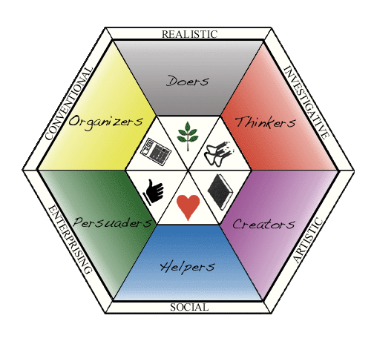

**Realistic**

* Likes to work with animals, tools, or machines; generally avoids social activities like teaching, healing, and informing others;
* Has good skills in working with tools, mechanical or electrical drawings, machines, or plants and animals;
* Values practical things you can see, touch, and use like plants and animals, tools, equipment, or machines; and
* Sees self as practical, mechanical, and realistic.

**Investigative**

* Likes to study and solve math or science problems; generally avoids leading, selling, or persuading people;
* Is good at understanding and solving science and math problems;
* Values science; and
* Sees self as precise, scientific, and intellectual.

**Artistic**

* Likes to do creative activities like art, drama, crafts, dance, music, or creative writing; generally avoids highly ordered or repetitive activities;
* Has good artistic abilities -- in creative writing, drama, crafts, music, or art;
* Values the creative arts -- like drama, music, art, or the works of creative writers; and
* Sees self as expressive, original, and independent.

**Social**

* Likes to do things to help people -- like, teaching, nursing, or giving first aid, providing information; generally avoids using machines, tools, or animals to achieve a goal;
* Is good at teaching, counseling, nursing, or giving information;
* Values helping people and solving social problems; and
* Sees self as helpful, friendly, and trustworthy.

**Enterprising**

* Likes to lead and persuade people, and to sell things and ideas; generally avoids activities that require careful observation and scientific, analytical thinking;
* Sees self as energetic, ambitious, and sociable.

**Conventional**

* Likes to work with numbers, records, or machines in a set, orderly way; generally avoids ambiguous, unstructured activities

**Emotion at work and career management:**

Emotion management skills refers to the ability to master your own emotion example if you have a fight with your wife and you are angery but at office you control your emotions and deal with your boss or client nicely you have done it. In your personal life, your reaction to stressful situations like these might be to start shouting, or to go hide in a corner and feel sorry for yourself for a while. But at work, these types of behavior could seriously harm your professional reputation, as well as your productivity.

**1) Don't surround yourself with worry and anxiety** –

For example, if co-workers gather in the break room to gossip and talk about job cuts, then don't go there and worry with everyone else. Worrying tends to lead to more worrying, and that isn't good for anyone.

2) **Try deep-breathing exercises** –

This helps slow your breathing and your heart rate. Breathe in slowly for five seconds, then breathe out slowly for five seconds. Focus on your breathing, and nothing else. Do this at least five times

3) **Focus on how to improve the situation** –

If you fear being laid off, and you sit there and worry, that probably won't help you keep your job. Instead, why not brainstorm ways to bring in more business, and show how valuable you are to the company?

4) **Write down your worries in a worry log** –

If you find that worries are churning around inside your mind, write them down in a notebook or "worry log," and then schedule a time to deal with them. Before that time, you can forget about these worries, knowing that you'll deal with them later.

**Organizational change and development:**

Organizational change is a process in which an organization changes its structure, strategies and methods or culture. Organizational change can be continuous or occurred in distinct of time.

**Change Management:**

Change management is the discipline that guides how we prepare, equip and support individuals to successfully adopt change in order to drive organizational success and outcomes.

While all changes are unique and all individuals are unique, decades of research shows there are actions we can take to influence people in their individual transitions. Change management provides a structured approach for supporting the individuals in your organization to move from their own current states to their own future states.

**Organizational development:**

It is a strategy which is planned and implemented from the top With a view to bring about planned change in the organization for the purpose Of increasing organizational effectiveness. The ultimate goal Of O.D. may be the creation Of a new team, changing the attitudes of organization members and developing new values. O.D. has problem solving approach. O.D. is a long range strategy for organizational innovation and renewal. Trained specialists are required.

**Human performance and the work environment:**

Human performance is key factor in workplaces. Its means from an organization’s point of view how the employees perform their task. And complete their work on given time.

**Individual differences in performance:**

Individual variability at work is a fact of life. People are different in skills and abilities many of them are doing a job according to there personality and motivation but the issue is that people are not always perform the task on the same way or same standard every time they do it and we have to accept that.

**Motivation:**

Keep the employees motivated

1-Communicate with them

2-Reward strong performance

3-Involve employees in decision making

**Human error:**

Humanerror is a mistake in the planning or execution of a task that results in failure to meet a goal. It is a category of business or organizational risk that can apply to a wide variety of tasks

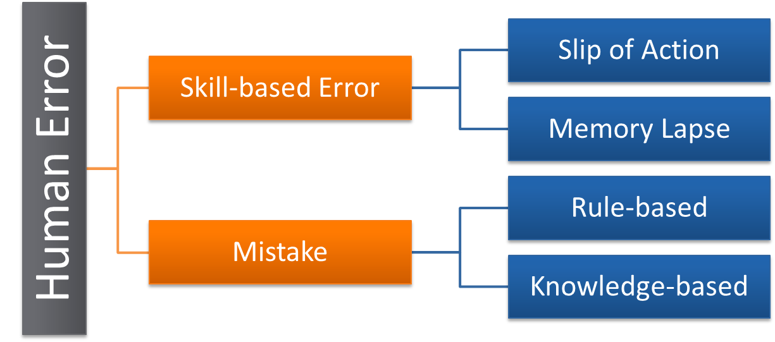

**Slip of action:**

Slip often occurs in routine activity. We intend to do one thing, but do another unintentionally.

**Memory Lapse:**

This type of error refers to instances of forgetting to do something.

**Rule-based mistakes:**

Occurs when our behaviors is based on remembered rules or familiar procedures

Example: if this happen we do that

**Knowledge-based mistakes:**

Occurs when we don’t have the knowledge but we tell them to do this this way (lack of expertise)

**Work Environment:**

Location where a task is completed. When pertaining to a place of employment, the work environment involves the physical geographical location as well as the immediate surroundings of the workplace, such as a construction site or office building. Typically involves other factors relating to the place of employment, such as the quality of the air, noise level, and additional perks and benefits of employment such as free child care or unlimited coffee, or adequate parking.



**Management Issues**

Job Satisfaction

While work can be source of stress, it can also be a key means of personal fulfillment and satisfaction.

A lack of Job Satisfaction is often characterized by psychological defensiveness, alienation and conflict.

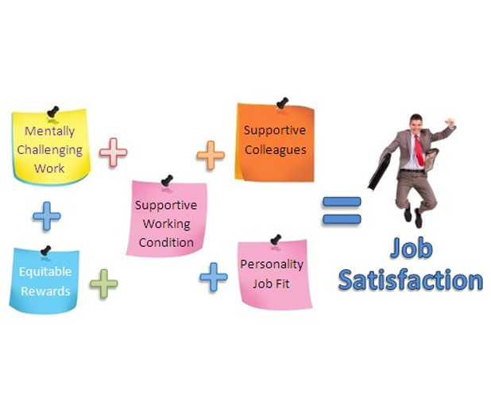

**Work Life Balance**

Work-life balance has been proposed as an individual’s right to a fulfilled personal and work life which is assumed as being to the mutual benefit of the individual, business and society.

**Assessment Research Methods**

➢ To recruit new people into the organization.

➢ To select existing employees for new posts.

➢ To select likely candidates for succession planning.

➢ To assess training and development needs.

➢ To assess people’s potential for promotion and career development.

➢ To assist in team building at work.

➢ To reassess people’s skills and aptitudes after injury or illness.

➢ To assist in equal opportunities audits.

An Overview of The Assessment Process:

• The vacancy is analyzed and the skills, aptitudes, and personal qualities required to do the job are established.

• A set of techniques are designed that will allow the organization to test whether candidates have the required skills so

successfully perform the job.

• Organizations may choose from a wide range of assessment methods, includinginterviews, psychometrictests, work

sample tests,and group exercises

• A pool of candidates are contacted and shortlisted for further assessment.

• A successful job candidate is selected.

Job Analysis:

• Interviews with members of the role set(people that the job incumbent needs to interact with in order to get the job

done).

• Diary studies (job incumbents may be asked to complete logs of their activity, including details of

‘critical ’incidents—any significant or difficult aspects of their work).

• Observation(which can be through job shadowing or participation in work).

• Archives and records(reports or information about the department and its work).

• Exit Interviews(an informal discussion with those leaving the organization to explore reasons for the move).

Assessments Methods:

• Interviews.

• Psychometric tests.

• Job sample tests.

• Group exercises.

• Assessments and development centers.

The Interview:

• Mental capacity.

• Personality tendencies.

• Applied social skills.

• Background credentials.

• Assess person-organization ‘fit’.

Integrative Techniques: Assessment And Development Centre’s:

Assessments Centre’s:

Assessment centers are a process,not a place, consisting of a collection of selection methods carried out over a period of

time,generally a day or two.They utilize individual and group techniques in order to gain a comprehensive set of data about

indivisuals suitability for a particular job and make predictions about the individual future job performance.

Development Centres:

Assessment and Development centres have much in common in terms of tools and processes but differ in term of

]Learning, Training And Development:

Understanding Learning and Development:

It’s amazing how so many of us go through so many years of schooling, but have such little understanding of learning and

development. Before reading about the many aspects of learning and development in this topic in the Library, including

learning and development programs and practitioners, it best to start with a basic understanding of what learning and

development is and how to best benefit from it. Also useful to understand the common terms and the sometimes subtle

differences between them.

If you will be doing training and development with yourself (and almost every adult will be at some time in their lives) or

with others, you should know the differences between training children and teens versus training adults. Adults have very

different nature and needs in training. Also, there are some common beliefs about training that just true. Understand

those misconceptions so you don’t build your training around those illusions.

Benefits of Learning and Development:

We often think that the biggest benefit of learning is that we get a diploma or credential. As we get wiser, we realize there

are so many more benefits than that. Knowing the benefits will help motivate you to design your own training plans and

programs, and to motivate others to participate as well. Perhaps one of the biggest benefits is the appreciation that you can

be learning all the time, even if you are not in a formal training.